SIMATS ENGINEERING

ASSESSMENT TOOL II — Visualization Analysis Report
Course: Data Handling and Visualization | Code: DSA0603 | CO: CO5
Duration: 180 min | Total Marks: 100 | Reg No : 192324275  Name: JAANA NITHISH

COURSE OUTCOME COVERED

CO5: Analyze and evaluate visualization choices to communicate patterns, comparisons, relationships, and potential misleading effects through appropriate visualization methods. (BL4)

Activity Tool : Visualization Analysis Report
Weightage: 20%

Code of Conduct:
I _JAANA NITHISH(192324275) _ (Name / Reg No) certify that this submission is my original work and that I have adhered to the guidelines specified for this assessment. I understand that any violation of academic integrity rules will result in disciplinary action.
Signature of the student: JAANA NITHISH

Assessment Criteria
Criteria | Visualization Selection and Understan ding 25% | Visualization Analysis and Interpret ation  25% | Applicati on of Visualizat ion Principles  20% | Organizatio n and Presentation 20% | Accurac y  10% | Clarit y  5% | Tot al
Q1
Q2
Q3

Q4
Q5

AT2 – Visualization Analysis Report | Data Handling and Visualization | DSA06 Visualization Analysis Report – Assessment Tool

R Programming Practical Questions with Datasets

Instructions: Answer all five questions. Use R programming to construct the required visualizations, analyze the patterns, compare visualization choices where requested, and identify potential visualization pitfalls. Use the given data exactly unless a transformation is explicitly requested.

Q1. Comparing Distributions – Histogram, Density and ECDF
A quality-control team records the following processing times (in minutes) for 20 randomly selected tasks. Using R, create a histogram and a density plot for the data. Also construct an empirical cumulative distribution function (ECDF). Compare the three visualizations and explain which aspects of the distribution—center, spread, skewness, and cumulative behavior—are communicated most clearly by each.
Data: Time = 18, 21, 22, 24, 25, 25, 27, 28, 29, 30, 31, 32, 33, 35, 36, 38, 41, 43, 46, 50
Expected R tasks: histogram, density estimation, ECDF, appropriate labels/scales, comparison and interpretation.
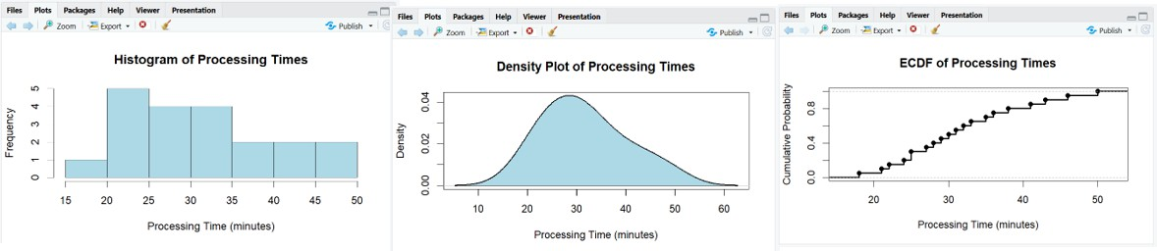

Histogram
- Divides the processing times into intervals or bins.

- Shows how frequently observations occur in each interval.
- The center is around 30–32 minutes.
- Most observations are between approximately 24 and 38 minutes.
- The larger values extending toward 50 minutes indicate some right-side tail.

Density Plot
- Provides a smoothed representation of the distribution.
- Makes the overall shape easier to observe than individual histogram bins.
- It shows where observations are concentrated.
- It suggests a relatively central concentration around the low-to-mid 30-minute range.

ECDF
- Shows the cumulative proportion of observations at or below each processing time.
- For example, it can directly answer questions such as: What proportion of tasks were completed within 35 minutes?
- It does not require choosing histogram bins.
- It clearly represents cumulative behavior.

Comparison
Visualization | Best for
Histogram | Frequency, center and overall spread
Density plot | Smooth distribution shape and skewness
ECDF | Cumulative probabilities and percentile behavior

Q2. Q-Q Plot and Normality Analysis
A researcher measures the following response times (in seconds). Use R to create a normal Q-Q plot and a histogram/density visualization. Assess whether the observations are reasonably consistent with a normal distribution. Identify any departures from the reference line and explain what they indicate about the distribution.

Data: Response = 42, 45, 47, 49, 50, 51, 52, 53, 54, 55, 56, 57, 58, 60, 61, 63, 66, 70, 76, 85
Expected R tasks: qqnorm()/qqline() or ggplot2 Q-Q plot, histogram/density plot, interpretation of deviations and outliers.
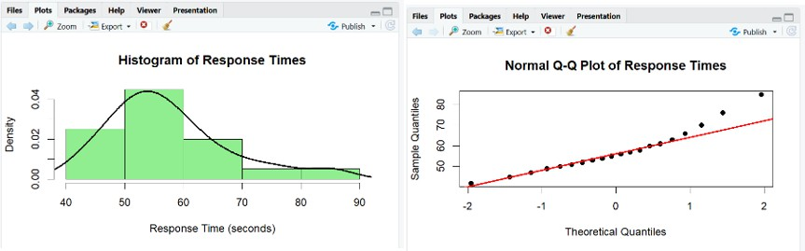

Explanation
The Q-Q plot compares the observed response times with theoretical values expected from a normal distribution.
- If observations follow a normal distribution, points should lie approximately along the reference line.
- Small deviations are normally acceptable.
- Large systematic deviations indicate non-normality.
- The value 85 seconds is relatively high compared with most observations and may contribute to deviation in the upper tail.
- The values 76 and 85 seconds extend the upper tail.

Q3. Visualizing Many Distributions at Once
Three groups of students have examination scores recorded below. Create a suitable visualization that compares the distributions of all three groups at once. Use boxplots and/or violin plots, and optionally overlay individual observations. Analyze differences in center, spread, and possible outliers. Explain why the selected visualization is more informative than displaying three separate plots.
Group A = 52,55,57,58,60,61,62,64,65,66,68,70,72,74,78; Group B = 45,49,51,53,55,56,58,59,60,62,63,65,67,69,71;

Group C = 58,60,61,63,64,65,67,68,70,71,72,74,76,80,84
Expected R tasks: data reshaping, grouped boxplot/violin plot, optional jitter, comparison of distributions, interpretation.
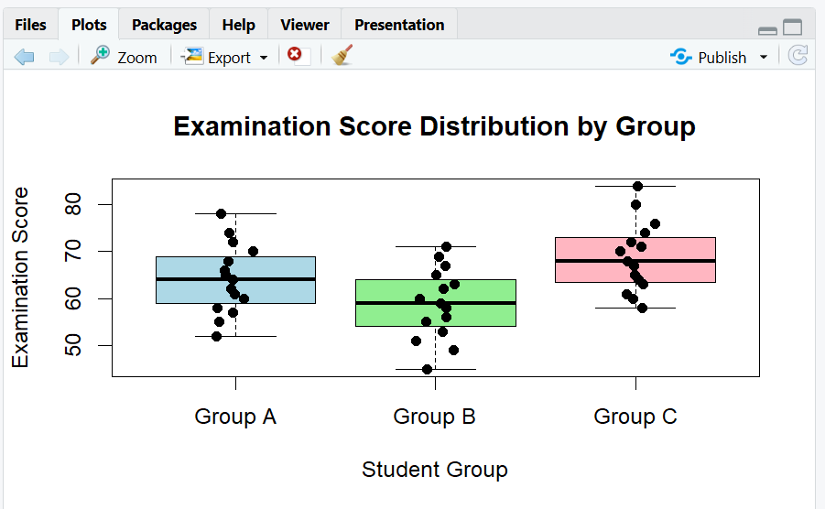
The boxplot displays the three groups side by side, making comparison easy. Group A
- Has a relatively high center.
- Scores range approximately from 52 to 78.
- The distribution is fairly broad.
Group B
- Has the lowest center among the three groups.
- Scores range from 45 to 71.
- Its lower scores indicate weaker overall performance compared with Groups A and C. Group C
- Has a high center, similar to or slightly above Group A.
- Extends from 58 to 84.
- Contains the highest observed score, 84.
Why One Combined Visualization Is Better

A single grouped visualization is more informative because:
- All three groups share the same y-axis.
- Centers can be compared immediately.
- Differences in spread are visible.
- Potential extreme values can be identified.
- Individual observations can be displayed without creating three separate graphs.
- The viewer does not need to mentally compare different axes.

Q4. Relationships and Multivariate Visualization

A study records advertising expenditure, website visits, and sales for 15 observations. Create a scatterplot of advertising expenditure versus sales and use an appropriate visual encoding to incorporate website visits. Add a fitted trend line. Analyze the strength and direction of the relationship and explain whether the additional variable improves the interpretation or risks cluttering the visualization.
Advertising = 10,12,14,16,18,20,22,24,26,28,30,32,34,36,38;
Visits = 120,135,150,165,180,195,210,225,245,260,275,290,305,320,340;
Sales = 48,50,53,55,58,61,63,66,69,71,74,77,80,83,86

AT2 – Visualization Analysis Report | Data Handling and Visualization | DSA06 Expected R tasks: scatterplot, trend line, third-variable encoding, appropriate legend/scale, relationship analysis and critique.
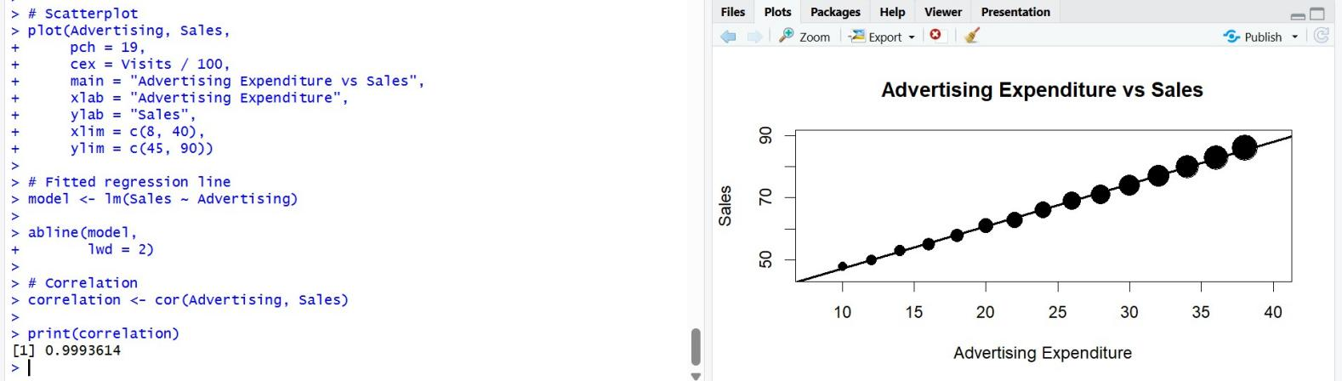

The scatterplot shows a clear positive relationship between advertising expenditure and sales. As advertising expenditure increases:
- Sales also increase.
- The points form a strong upward pattern.
- The fitted regression line confirms the positive trend.
Website visits are represented using point size.
Larger points represent higher numbers of website visits, while smaller points represent fewer visits.
Relationship Analysis
The relationship between advertising expenditure and sales is strongly positive. For example:
- Advertising = 10 → Sales = 48
- Advertising = 24 → Sales = 66
- Advertising = 38 → Sales = 86
This demonstrates that higher advertising expenditure is associated with higher sales.
Website visits also increase along with advertising expenditure, providing additional context for interpreting the relationship.

Q5. Misleading Visualization and Redesign
A college reports the following pass percentages for seven departments. Create two visualizations: (1) a misleading version using a truncated y-axis and an inappropriate visual emphasis, and (2) a redesigned version using an appropriate baseline, ordered categories, and clear labels. Compare the two plots and explain how the first visualization can exaggerate differences and why the redesigned visualization communicates the data more honestly.
Department = CSE, ECE, EEE, MECH, CIVIL, AIDS, IT;
Pass_Percentage = 91,93,92,89,90,95,94
Expected R tasks: bar chart with controlled y-axis, redesigned bar chart, ordering, labels, misleading-axis critique, accessibility and communication analysis.

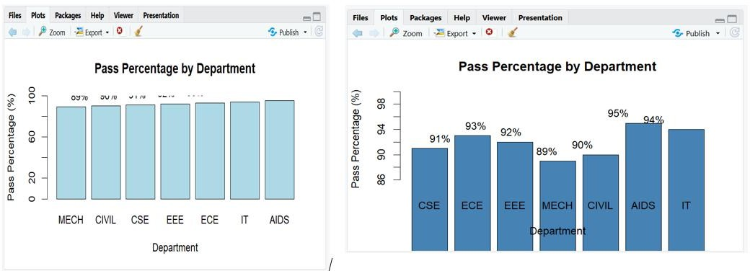

The y-axis begins at 85% instead of 0%. The actual differences are small:
- CIVIL = 90%
- AIDS = 95%
The difference is only 5 percentage points.
However, because the graph starts at 85%, the bars visually appear much more different than the data justify.
For example, the 95% bar appears approximately twice as tall as the 90% bar relative to the displayed baseline, even though 95% is only about 5.6% higher than 90%.
The redesigned graph:
- Starts the y-axis at 0%.
- Orders departments from lowest to highest pass percentage.
- Displays exact percentage labels.
- Uses a simple bar design.
- Makes the actual differences easier to interpret.
- Avoids unnecessary decorative elements.

